

(ISO 9001:2015 Certified), Accredited with ‘A’ Grade by NAAC

: 08258 - 281039 – 281263, Fax: 08258 – 281265

### Department of Computer Science and Engineering

B.E. CSE Program Accredited by NBA, New Delhi from 1-7-2018 to 30-6-2021

Report on Mini Project

Crime Record Management System

#### Course Code : 18CS502

#### Course Name : DBMS

##### Semester: V SEM Section: A

**Submitted To:**

## Dr. Sudeepa K.R

## Department of Computer Science & Engineering

**Submitted By:**

Bhavish - 4NM18CS037

Blen Joswin -4NM18CS039

Dhanush Raj-4NM18CS048

**Date of submission:**

28/12/2020

#### Signature of Course Instructor

# ABSTRACT

The aim of Crime Record Management System project is to develop an online crime report and managing system which is used by the police department and the administrative department for easy monitoring of criminal/case data.

This system registers the complaints from people through police and stored in database and progress of each case is monitored which provides a way for efficient handling of a case and it's data.

# 

# INTRODUCTION

A crime is an unlawful act punishable by a state or other authority.It is part of outlaw activities in human life. It’s quite obvious that the speed of crimes is increasing day by day all over the societies across the globe, however we tend to do be live that there’s loads which may be done by each the governments and therefore the people to cut back the crimes in communities. Hence, here we tend to propose a web crime reportage system that provides a way to store the complete information of the case ,misconduct reports and keep a track of it. To file a FIR, the police incharge takes complaint from people and registers it and uploads the information to the database.

The crime management system can help in storing the records related to the criminals, cases, complaint record, case history and so on. This allows to enter or delete the records if necessary. All these records can be maintained in a single database.

# DESIGN

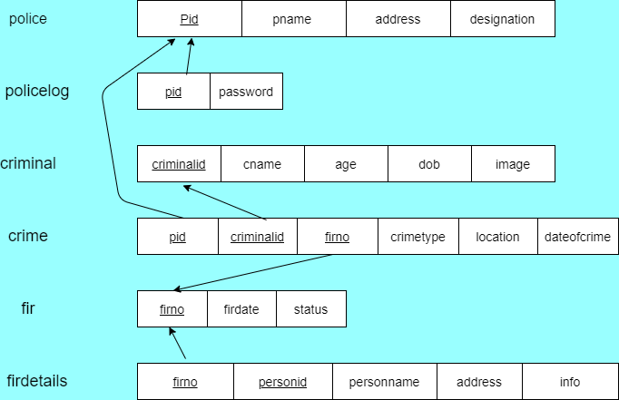

ER Diagram:

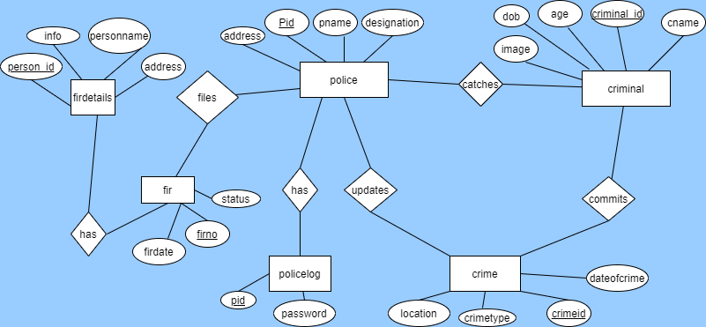

# IMPLEMENTATION

1. Home Page: Home page is just first page of our project.It contains general information.
2. Login Page:Login as the police officer.
3. Add Police Page:If you are logging for first time,we must create new account for the officer.
4. Add FIR Page:Here we can add FIR.
5. Page 5:After we add successful addition of FIR,we come to this page.
6. Search Criminal Page:Here we can search the criminal we have entered before.
7. Criminal Details:Here we receive the searched criminal details.

8] Criminal Record:Here we receive more details and about the criminals.

# 

# RESULT AND DISCUSSIONS

**1]Home Page**

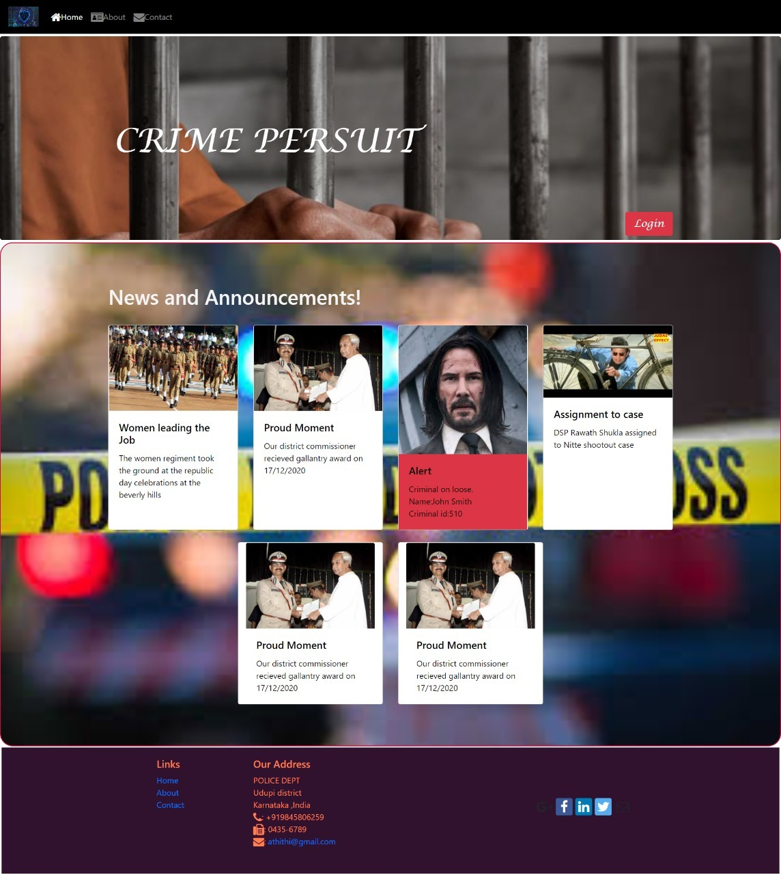

2]Login Page



3]Add Police Page



4]Add FIR

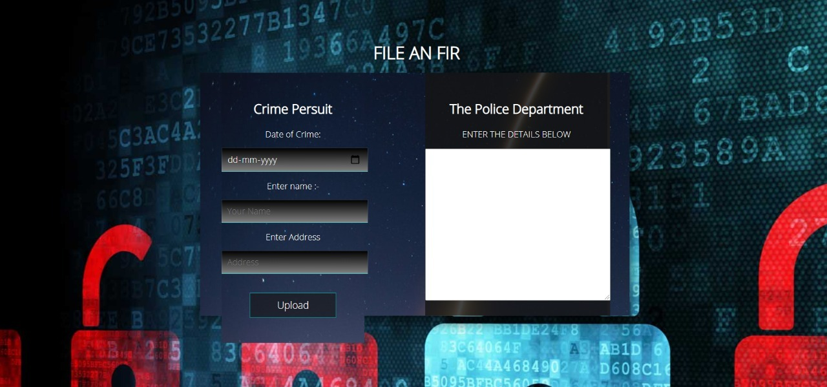

5]Success Message



6]Search Criminal Page



7]Display Required Criminal



8]Criminal Record

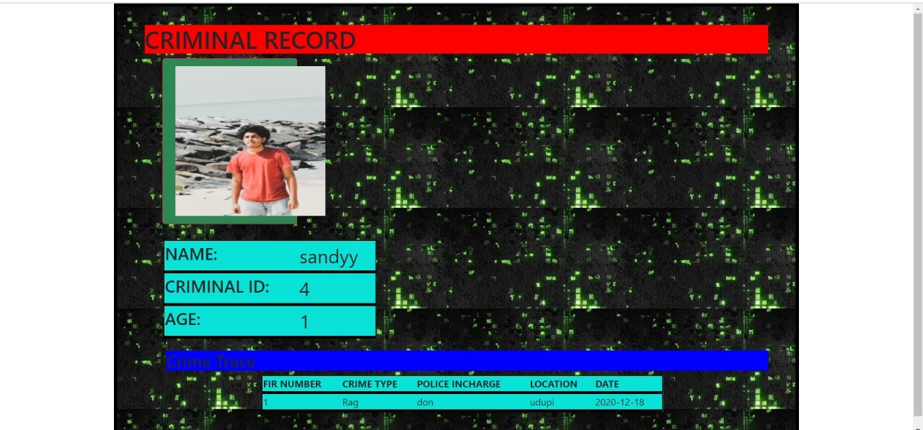

# CONCLUSION

This website contains all the basic information required for the user. It has a user-friendly interface.

Much needed functionalities have been implemented in this version.

A database which is just enough to fulfill the necessities of the project has been implemented without giving up on the basic database constraints.

Future implementations will include:

1] Fir details search section

2] Navigation to various sections after login

3] Password Recovery and modification

4] Complaints section for users